RMI stands for Remote Method Invocation.
- It is a mechanism that allows an object residing in one system (JVM) to access/invoke an object running on another JVM.
- RMI is used to build distributed applications;
- it provides remote communication between Java programs. It is provided in the package java.rmi.

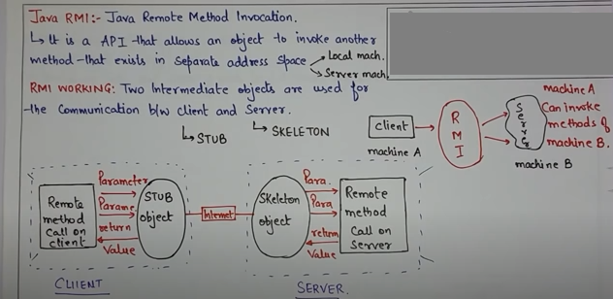

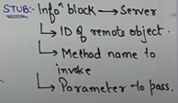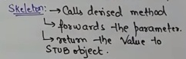

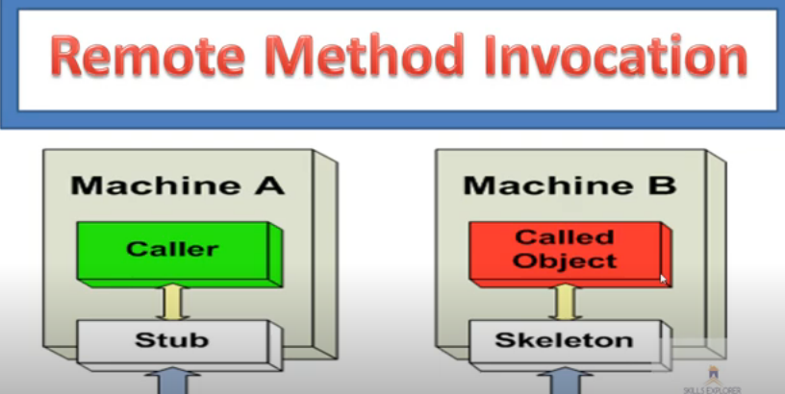

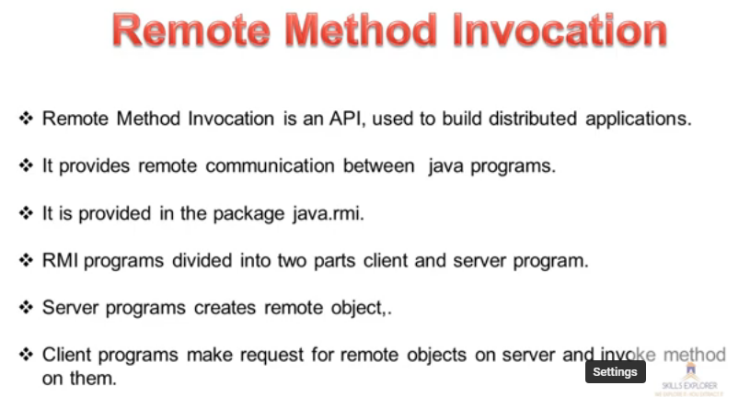

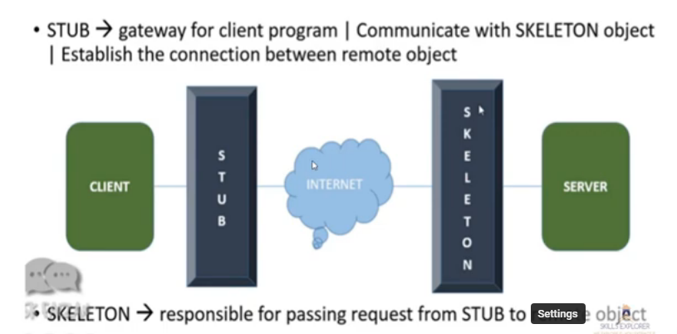
Remotev object*

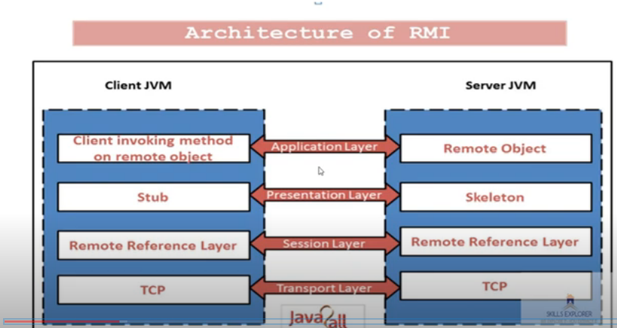

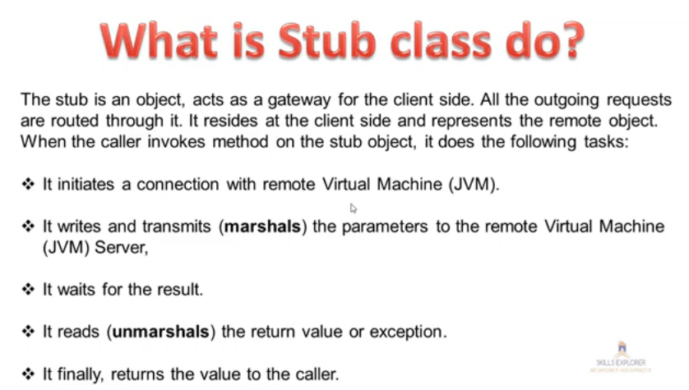

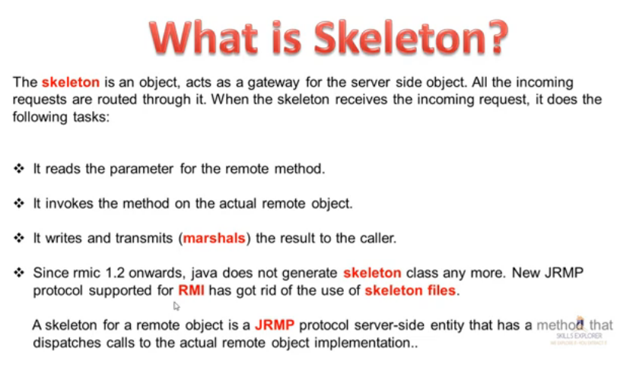

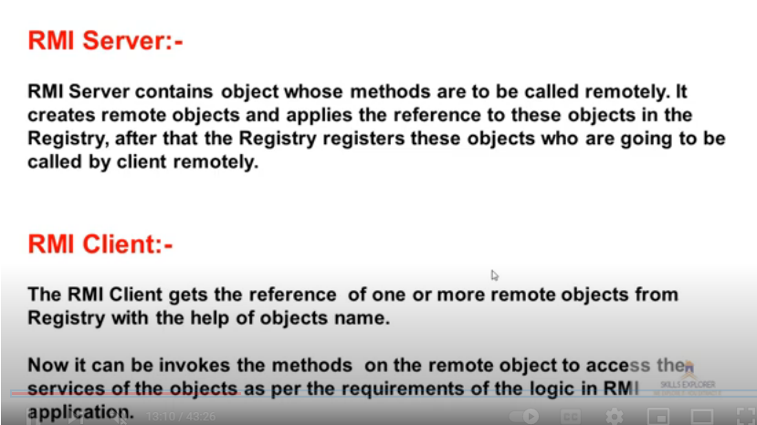
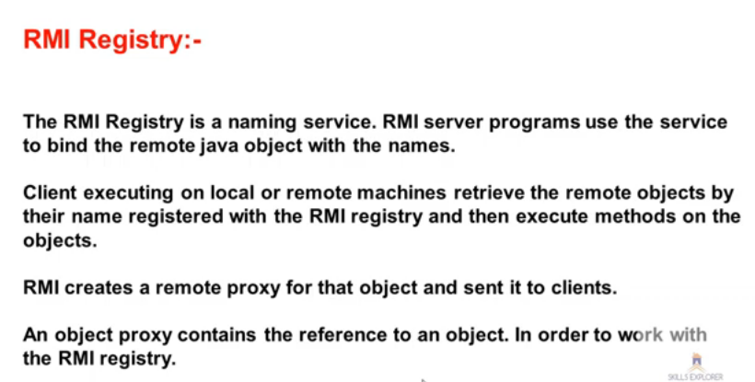

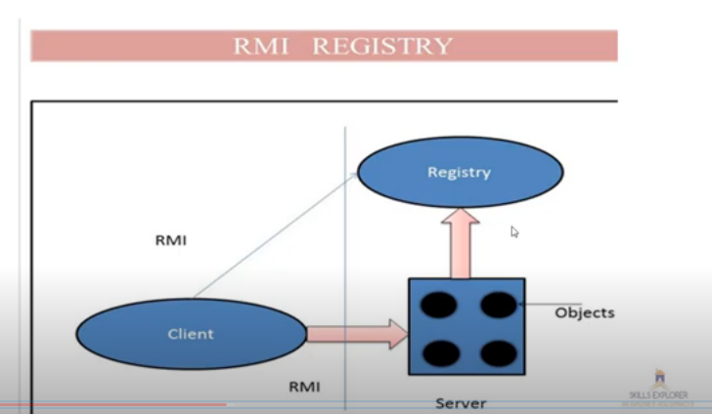

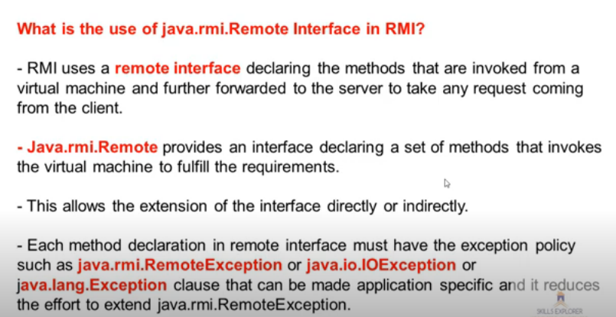

Architecture of an RMI Application
In an RMI application, we write two programs, a server program (resides on the server) and a client program (resides on the client).
- Inside the server program, a remote object is created and reference of that object is made available for the client (using the registry).
- The client program requests the remote objects on the server and tries to invoke its methods.
The following diagram shows the architecture of an RMI application.

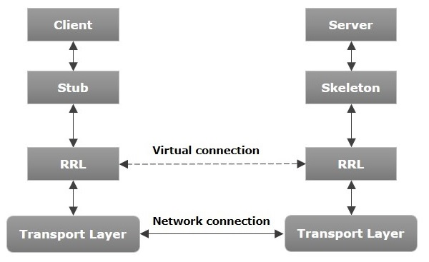
Let us now discuss the components of this architecture.
- Transport Layer − This layer connects the client and the server. It manages the existing connection and also sets up new connections.
- Stub − A stub is a representation (proxy) of the remote object at client. It resides in the client system; it acts as a gateway for the client program.
- Skeleton − This is the object which resides on the server side. stub communicates with this skeleton to pass request to the remote object.
- RRL(Remote Reference Layer) − It is the layer which manages the references made by the client to the remote object.

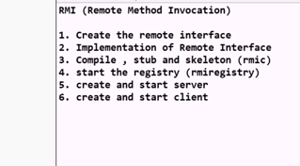

Working of an RMI Application
The following points summarize how an RMI application works −
- When the client makes a call to the remote object, it is received by the stub which eventually passes this request to the RRL.
- When the client-side RRL receives the request, it invokes a method called invoke() of the object remoteRef. It passes the request to the RRL on the server side.
- The RRL on the server side passes the request to the Skeleton (proxy on the server) which finally invokes the required object on the server.
- The result is passed all the way back to the client.

Marshalling and Unmarshalling
Whenever a client invokes a method that accepts parameters on a remote object, the parameters are bundled into a message before being sent over the network. These parameters may be of primitive type or objects. In case of primitive type, the parameters are put together and a header is attached to it. In case the parameters are objects, then they are serialized. This process is known as marshalling.
At the server side, the packed parameters are unbundled and then the required method is invoked. This process is known as unmarshalling.

RMI Registry
RMI registry is a namespace on which all server objects are placed. Each time the server creates an object, it registers this object with the RMIregistry (using bind() or reBind() methods). These are registered using a unique name known as bind name.
To invoke a remote object, the client needs a reference of that object. At that time, the client fetches the object from the registry using its bind name (using lookup() method).
The following illustration explains the entire process −
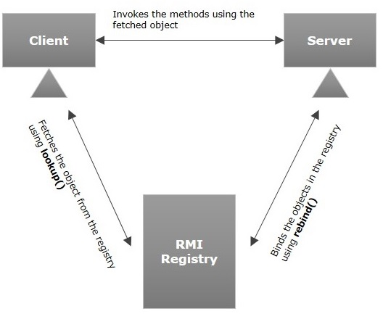

OR

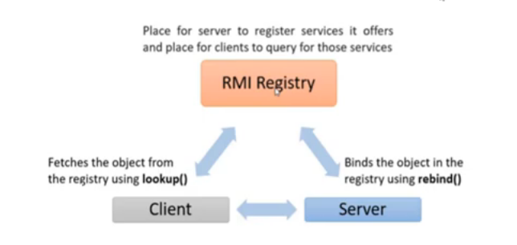

Goals of RMI
Following are the goals of RMI −
- To minimize the complexity of the application.
- To preserve type safety.
- Distributed garbage collection.
- Minimize the difference between working with local and remote objects.

RMI Example
In this example, we have followed all the 6 steps to create and run the rmi application. The client application need only two files, remote interface and client application. In the rmi application, both client and server interacts with the remote interface. The client application invokes methods on the proxy object, RMI sends the request to the remote JVM. The return value is sent back to the proxy object and then to the client application.

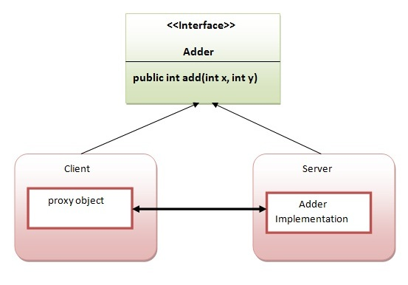

1) create the remote interface (Adder.java)
For creating the remote interface, extend the Remote interface and declare the RemoteException with all the methods of the remote interface. Here, we are creating a remote interface that extends the Remote interface. There is only one method named add() and it declares RemoteException.
import java.rmi.*;
public interface Adder extends Remote{
public int add(int x,int y)throws RemoteException;
}

2) Provide the implementation of the remote interface (AdderRemote .java)
Now provide the implementation of the remote interface. For providing the implementation of the Remote interface, we need to
- Either extend the UnicastRemoteObject class,
- or use the exportObject() method of the UnicastRemoteObject class
In case, you extend the UnicastRemoteObject class, you must define a constructor that declares RemoteException.
import java.rmi.*;
import java.rmi.server.*;
public class AdderRemote extends UnicastRemoteObject implements Adder{
AdderRemote()throws RemoteException{
super();
}
public int add(int x,int y){return x+y;}
}

3) create the stub and skeleton objects using the rmic tool.
Next step is to create stub and skeleton objects using the rmi compiler. The rmic tool invokes the RMI compiler and creates stub and skeleton objects.
- rmic AdderRemote

4) Start the registry service by the rmiregistry tool
Now start the registry service by using the rmiregistry tool. If you don't specify the port number, it uses a default port number. In this example, we are using the port number 5000.
- rmiregistry 5000 or start rmiregistry

5) Create and run the server application
Now rmi services need to be hosted in a server process. The Naming class provides methods to get and store the remote object. The Naming class provides 5 methods.
public static java.rmi.Remote lookup(java.lang.String) throws java.rmi.NotBoundException, java.net.MalformedURLException, java.rmi.RemoteException; | It returns the reference of the remote object.
public static void bind(java.lang.String, java.rmi.Remote) throws java.rmi.AlreadyBoundException, java.net.MalformedURLException, java.rmi.RemoteException; | It binds the remote object with the given name.
public static void unbind(java.lang.String) throws java.rmi.RemoteException, java.rmi.NotBoundException, java.net.MalformedURLException; | It destroys the remote object which is bound with the given name.
public static void rebind(java.lang.String, java.rmi.Remote) throws java.rmi.RemoteException, java.net.MalformedURLException; | It binds the remote object to the new name.
public static java.lang.String[] list(java.lang.String) throws java.rmi.RemoteException, java.net.MalformedURLException; | It returns an array of the names of the remote objects bound in the registry.
In this example, we are binding the remote object by the name sonoo.
import java.rmi.*;
import java.rmi.registry.*;
public class MyServer{
public static void main(String args[]){
try{
Adder stub=new AdderRemote();
Naming.rebind("rmi://localhost:5000/sum",stub);
}catch(Exception e){System.out.println(e);}
}
}

6) Create and run the client application
At the client we are getting the stub object by the lookup() method of the Naming class and invoking the method on this object. In this example, we are running the server and client applications, in the same machine so we are using localhost. If you want to access the remote object from another machine, change the localhost to the host name (or IP address) where the remote object is located.
import java.rmi.*;
public class MyClient{
public static void main(String args[]){
try{
Adder stub=(Adder)Naming.lookup("rmi://localhost:5000/sum");
System.out.println(stub.add(34,4));
}catch(Exception e){}
}
}

For running this rmi example,

1) compile all the java files

javac *.java

2)create stub and skeleton object by rmic tool

rmic AdderRemote

3)start rmiregistry in one command prompt

Start rmiregistry or rmiregistry 5000

4)start the server in another command prompt

java MyServer

5)start the client application in another command prompt

java MyClient

Output of this RMI example

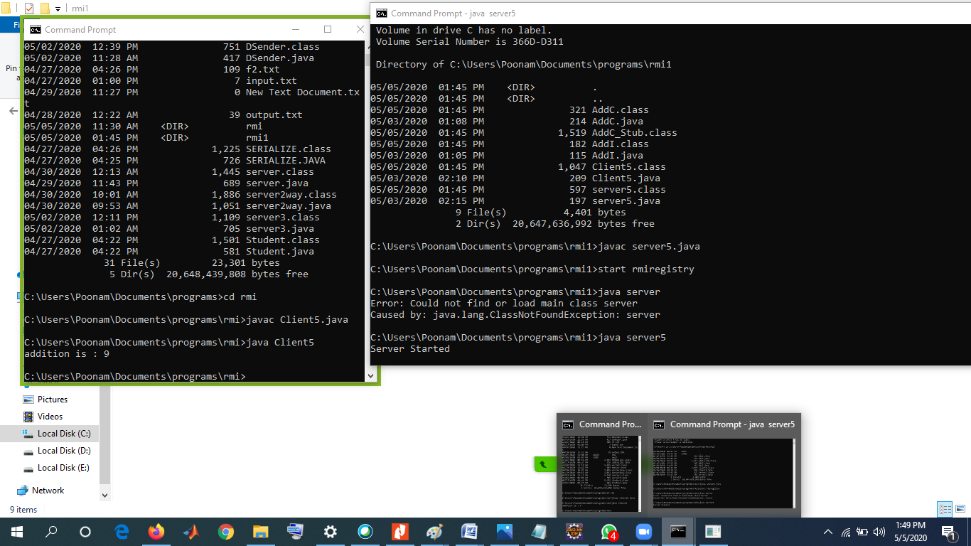
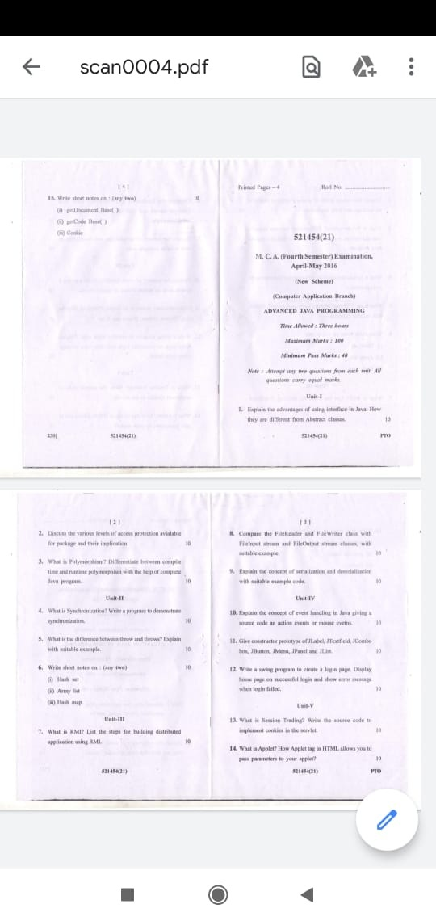
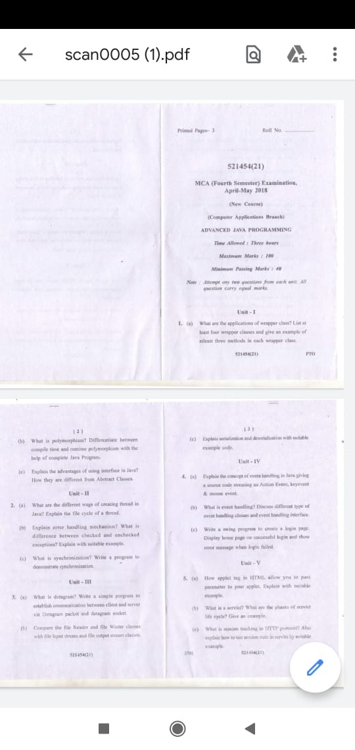
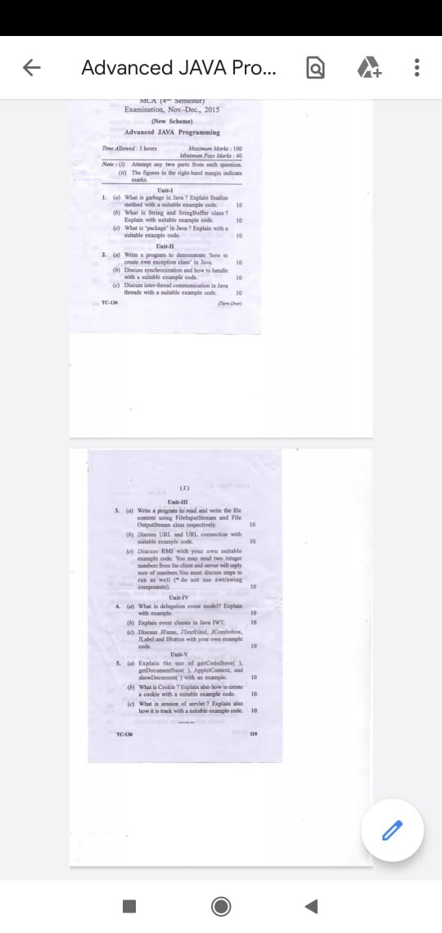

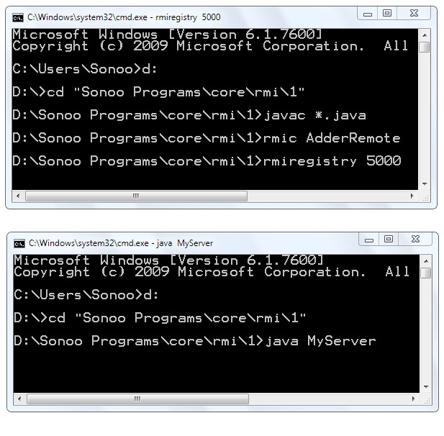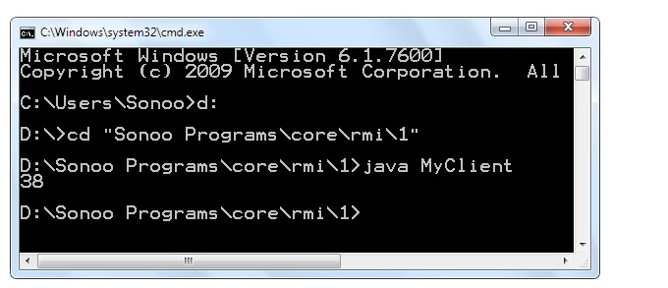

https://www.javatpoint.com/RMI
https://www.youtube.com/watch?v=bGrQ0v12rVY

